**Learning the basics of Web Development**

Over the course of the first term, I have spent countless hours learning the basics of Web Development. I have attended all classes since the start of the term up to the end and continue to struggle with web development. The entire process of creating the portfolio website I have found extremely difficult, I have watched all the collaborative classes in my own time.

From the start of this whole process, I have however enjoyed the design side of things, I enjoy being creative and designing different things, so creating wireframes I found fun and interesting. I used trial and error to come up with different designs, however my final website didn’t end up exactly how I designed it.

When coding the website, I struggled with positioning images and text, it took a lot of research to find out different techniques and ways of doing this correctly. However, towards the end of the development I started to become more fluent in typing out CSS code from memory and not having to refer to older code.

The debugging process of this was by far the easiest, I used an online validator which gave me the issues that were in my code, from this I was able to see what was wrong and solve the issue almost instantly. There wasn’t very many issues however, but when there was they were fairly major ones.

**How it was developed**

When creating the website, I done each page in a step by step format.

First, I created the wireframes for each of the pages on the website, these are shown below;

**Desktop Wireframes**

**Mobile Wireframes**

Once I had done this, I was ready to start on the index page.

Index.html

Design from original wireframe slightly changes with the color pallet used.

Once the wireframe was completed, I did a small amount of research on different sites to get some ideas on how sites are developed.

Firstly, I created the navigation for the website, although the navigation didn’t actually do anything as of yet it was in place ready with the correct names and code to link each link to the different pages, except they didn’t quite go anywhere yet. The navigation changed a few times within the development, it started out being just a navigation bar at the top right corner, with no special features, however now, when you hover over each of the links, they turn blue to identify which one you are hovered over.

Next, I created the first bit of text within the center of the page, this text simply just said “Hello, my name is Aidan” the text looked very basic and boring and wasn’t very interesting to look at or read, to make it look interesting, I had a look at a few different fonts (Using google web fonts) to see what would suit my webpage and tested a few different ones, the font I decided I felt would suit my page based on the design I had in place, at this stage. I was yet to add a background video where the text would be placed in front of.

Next, I found myself an image to put on my index page, originally, I was going to use something technology related, but then I couldn’t find a suitable image to fit my color scheme, so I settled with a picture of a dog. Later down the development line however I changed this image to be a picture of something technology related. I tried a few different images but finally settled with the one shown below. I made the image look interesting by rounding the corners by different percentages (Using border radius) to make them look more original compared to other sites. When hovering over the image, it changes color to gray, this is to add originality and interactivity within the page

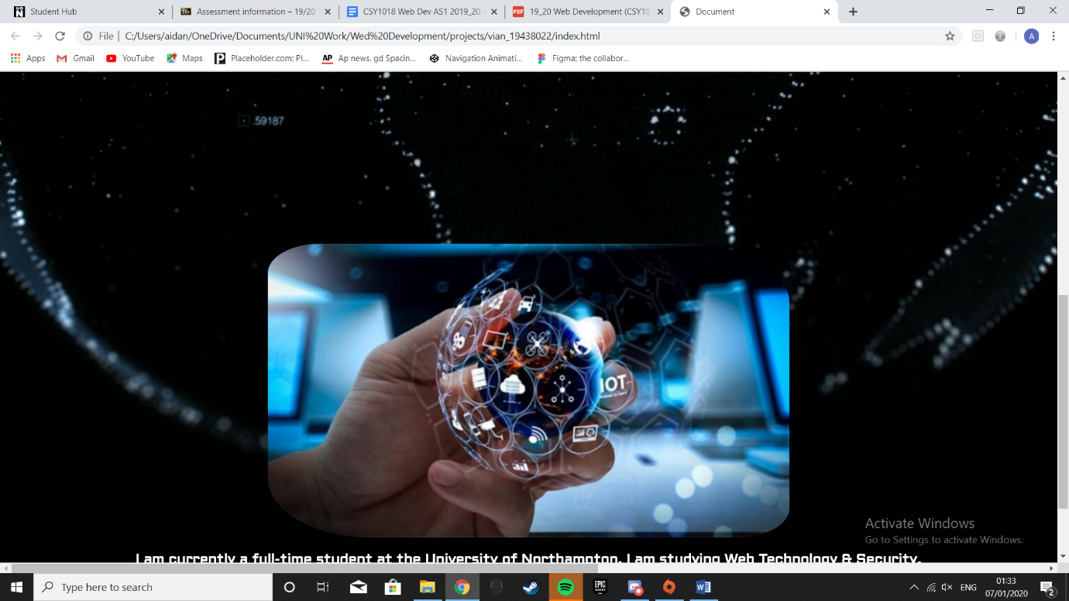

Next, I added a background video at the top of the page which had 2 different gradients, which went from blue to green. Once I had done this and added the text within the middle, I decided I would rather have the video playing as the background of the page to add originality, from the sites I looked at I didn’t see this idea done before. However, this design wasn’t consistent throughout the different pages. Due to the inconsistency and unprofessionalism of the webpage with the video included, I soon decided to remove the image completely, I personally prefer it without the video as it keeps the focus of the page being the content within it, not background videos.

Next, I added more text, explaining who I am, which was placed underneath the image, this just used the same font as the text from earlier but with a different size.

Next, I added social media links, at this stage I only had a Facebook link to test if it would work, however later in development a few more were added.

Portfolio.html

After creating the index.html page, I started working on the portfolio page.

Firstly, I copied the code for the navigation and implemented it here but changed it so that it was set to the portfolio page, not the index page. This hasn’t changed since the index page.

Next, I set the background to the page. Currently, the page is the color Cyan. At first, this color seemed okay, but later in development I decided to change the color to be gray, this decision was done because it makes the site look more professional and less child-like.

Next, I used a grid format to create the different links to my projects. However, currently I have no projects to show on this page, so the links don’t do anything. When these are hovered over, they show a slight shadow border around them to indicate which one you are hovered over.

After this, I noticed that I needed to add a back to top button as the page scrolls down a little bit. This adds more interactivity and makes it easier for the user to return to the top of the page.

This page was a lot easier to create compared to the index page because I had a lot more knowledge going into creating this page compared to when I started the index page.

Cv.html

After creating the portfolio.html page, I started working on the cv page.

Firstly, I copied the navigation code over to this page, it hasn’t changed in any way.

Next I started to write out my CV.

After reading through my code and noticing some issues when testing this page and other pages I couldn’t seem to discover the issues that I had, this was due to my code being messy and in random places and not properly commented, the way I solved this issue was by starting again, I copied the relevant code piece by piece onto a new .html file where I started again from the index page, doing this helped me improve the readability of my code as I have properly laid it out and commented everything correctly. This was the first major issue I ran into with my code. Due to the code not being very readable, it set me back a few hours as I had to make sure everything was correct before I could move on. However, once I had solved everything, my code was working properly and looked neat and tidy within the .css and all the .html pages.

After the issues were resolved, I noticed, I hadn’t used flexbox to create my CV, so I did some research onto what flexbox was and found a useful site which gave a tutorial on how to use flexbox. Once I gained a better understanding of what flexbox is and how to use it, I implemented it into my CV page.

After doing some testing, I realized that my site wasn’t responsive. However, I knew that it needed to be. I already had a vague idea on how to do this, which was by using media queries, however I wasn’t quite sure what the code was to actually do a media query, so I done a bit of research to gain a bit more knowledge on how they actually work and how to use them to refresh my memory and started working on making my website responsive. While doing this I did run into a few extra problems, such as text not aligning properly etc. however, these were easy fixes which just required me to delete certain lines of code, for example, on the portfolio page, the text at the top wouldn’t go underneath the navigation, the reason this was, is because I set the text to align to the left and not the center, once this was figured out, solving other issues was fairly easy. A short time later, my site was responsive.

Contact.html

Once I had completed the CV page, I moved onto the contact page. There were a few issues with this when I started, I wasn’t quite sure how to create something like this, so I had to do some research to learn how to do this sort of thing within HTML and CSS. Once I had looked at a few different things I felt ready to start, I already had a basic design which stayed the same throughout, however, it had a slight color change.

First, I created a variable box with a placeholder for user inputs. These allow for the user to enter text within these boxes. Once I had done this, I positioned them to the center of the screen, next to these on the left I had text telling users what these boxes require.

Once this was done I added a button which is suppose to send a email to me however, this doesn’t actually do anything, except displays a box saying Message received.

Once this was done, I used a HTML and CSS code validator, which is discussed below.

**Validation HTML**

Index

Here is the first issue. All that was missing was a <html> tag at the start

